Cheri L. Blount
Interim DSS Director
Chowan County Department of Social Services
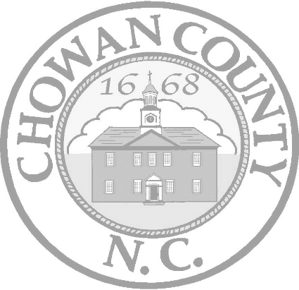
100 W. Freemason Circle Edenton, NC 27932
(252) 482-7441
(252) 482-7041 fax

Gertha Bond-Thomas
DSS Board Chair

VACANCY ANNOUNCEMENT
POSITION: Social Services Director
LOCATION: Chowan County
100 W. Freemason Circle Edenton, North Carolina 27932
SALARY: $56,513 - $95,920
OVERVIEW: Chowan County Board of Social Services is seeking a Director of Social Services to lead the agency. The Director serves as the executive officer of the County board of social services executing the authority of the Board as defined in GS 108A—14. The successful candidate will manage a variety of required programs in the county which employs 30 employees. Chowan County DSS has an operating budget of approximately $3.2 million. This position represents as the Department Head for Social Services functions within the county. Work involves representing the agency with government officials, human services providers and advocacy groups to ensure adequate resources for program maintenance and delivery of services.

JOB SPECIFICATIONS: Must possess a thorough knowledge of the legal and philosophical basis for public welfare programs. Considerable knowledge of principles and practices of social work. Thorough knowledge of management principles, techniques, and practices. Knowledge of DSS agency’s organization, operation and objectives and applicable Federal and State laws, rules and regulations. Ability to exercise sound judgment in analyzing situations and making decisions; direct managers/supervisors, professional, paraprofessional and support staff in the delivery of agency services and provides leadership and direction for program development, establishing program standards and monitoring and evaluating quality of service delivery system. Develop and maintain effective working relationships with the general public and with Federal, State, and Local Officials.
TRAINING AND EXPERIENCE: Master’s degree in social work and two years of supervisory experience in the delivery of client services; or a Bachelor’s degree in social work and three years of supervisory experience in the delivery of client services, one of which must have been in Social Services; or graduation from a four-year college or university and three years of supervisory experience in the delivery of client services, two of which must have been in the delivery of client services, two of which must have been in Social Services; or an equivalent combination of training and experience. The Director serves as Executive Officer of the County Board of Social Services executing the authority of the Board as defined in G.S. 108-A-14.

CLOSING DATE: Open until filled.
Chowan County is an Equal Opportunity Employer. This position is FLSA exempt. Final applicants are subject to a pre-employment drug screening and background check.

APPLICATION PROCESS: Interested candidates must submit a completed N.C. State application (PD 107) and official transcripts to:

Gertha Bond-Thomas, Social Services Board Chair
Attn: Mary F. White
100 W. Freemason Circle Edenton North Carolina 27932

